|  |  |
| --- | --- |
| Name: Hassan Bin Majid  _______________ | EE-272L Digital Systems Design |
| Reg. No.: 2023-EE-019  ____________ | Marks Obtained: ____________ |

**Lab Manual**

|  |  |  |  |  |  |
| --- | --- | --- | --- | --- | --- |
| **DSD Lab Manual Evaluation Rubrics** | | | | | |
|  |  |  |  |  |  |
| **Assessment** | **Total Marks** | **Marks Obtained** | **0-30%** | **30-60%** | **70-100%** |
| Code Organization (CLO1) | 3 |  | No Proper Indentation and descriptive naming, no code organization.  Zero to Some understanding but not working | Proper Indentation or descriptive naming or code organization.  Mild to Complete understanding but not working | Proper Indentation and descriptive naming, code organization.  Complete understanding, and proper working |
| Simulation (CLO2) | 5 |  | Simulation not done or incorrect, without any understanding of waveforms | Working simulation with errors, don't cares's(x) and high impedance(z), partial understanding of waveforms | Working simulation without any errors, etc and complete understanding of waveforms |
| FPGA (CLO2) | 2 |  | Not implemented on FPGA and questions related to synthesis and implementation not answered. | Correctly Implemented on FPGA or questions related to synthesis and implementation answered. | Correctly Implemented on FPGA and questions related to synthesis and implementation answered. |

**Procedure and Observations**

**Applying 5V at Terminal A**

* **Measured voltage at Terminal B**: 0 V (Zero Volts)
* **LED Status**: Not Glowing
* **Reason**: When 5 volts are applied to terminal A the insulation gap between Gate and Source decreases and Source is grounded. Thus that’s why LED don’t glows. As shown in Figure 1 and Figure 2.

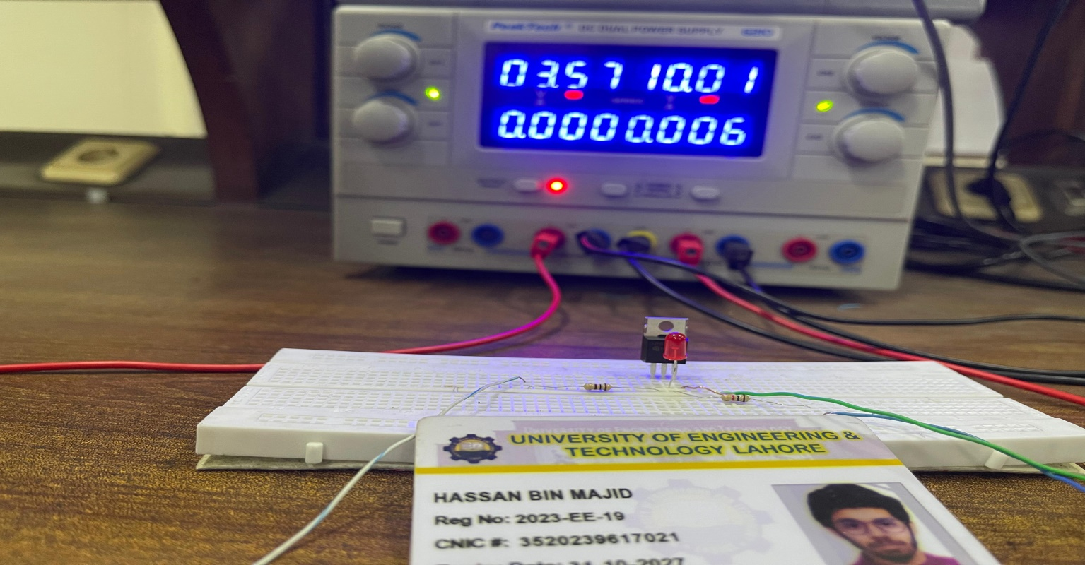Figure 1. LED is OFF when 3.57 volts are applied at terminal A.

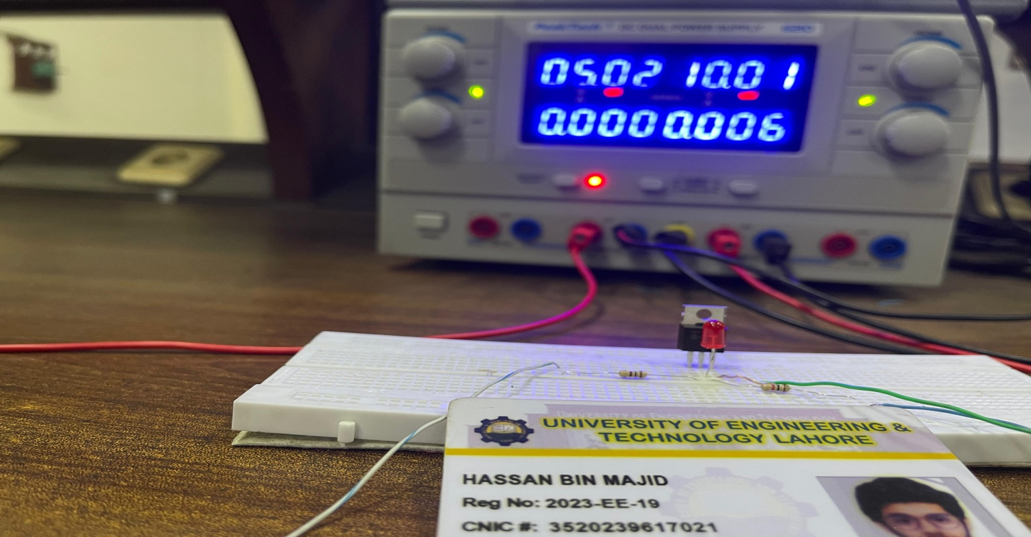

Figure 2. LED is OFF When 5 volts are applied at terminal A.

**Applying 0V at Terminal A**

* **Measured voltage at Terminal B**: 10.21 V
* **LED Status**: Glowing
* **Reason**:When 0 volts are applied to terminal A the insulation gap between Gate and Drain decreases and Source is grounded. Thus that’s why LED glows. As shown in Figure 3.

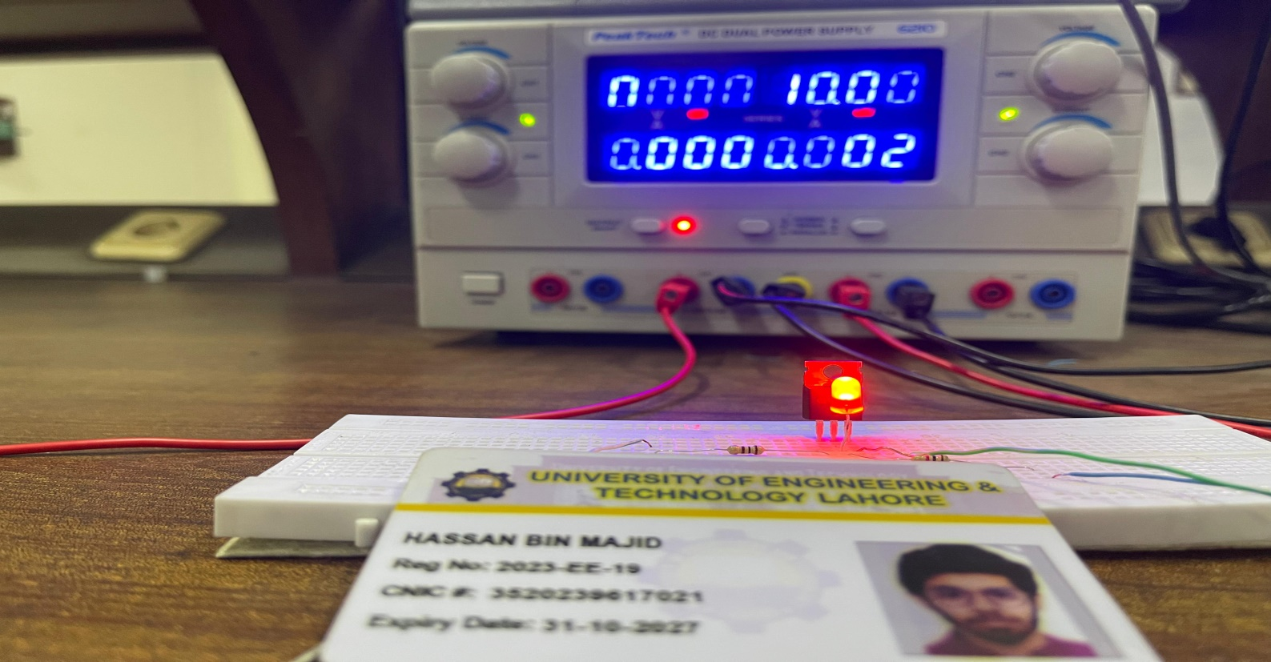

Figure 3. LED is ON When 0 volts are applied at terminal A.

**Applying a 1 kHz & 100kHz, 5V Peak Voltage Square Wave at Terminal A**

The input and output waves after applying 5kHz square wave at the terminal A observed from CRO with the time delays are shown in Figure 4 and Figure 5.

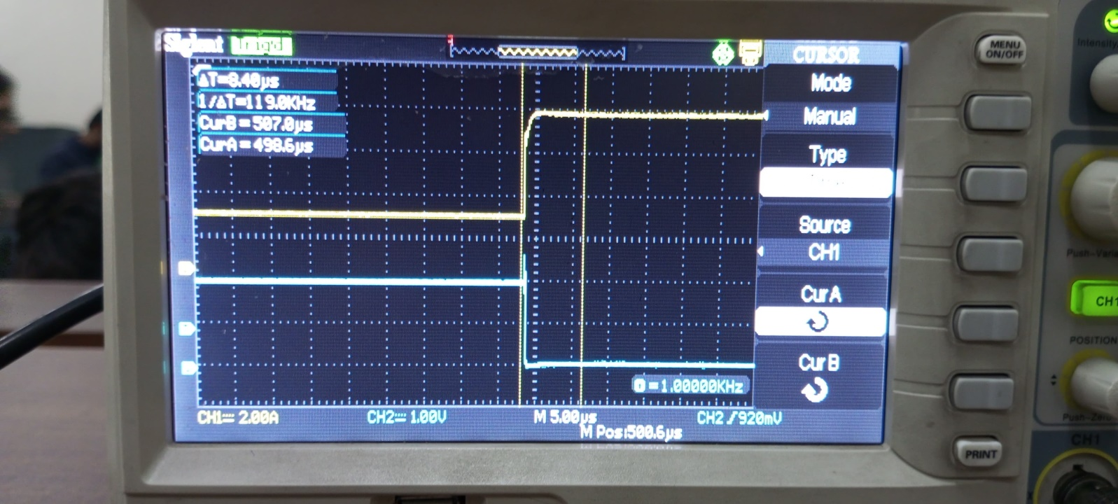

Figure 4. Input and Output waves with time delay when input is from Low to High and Output is from High to Low.

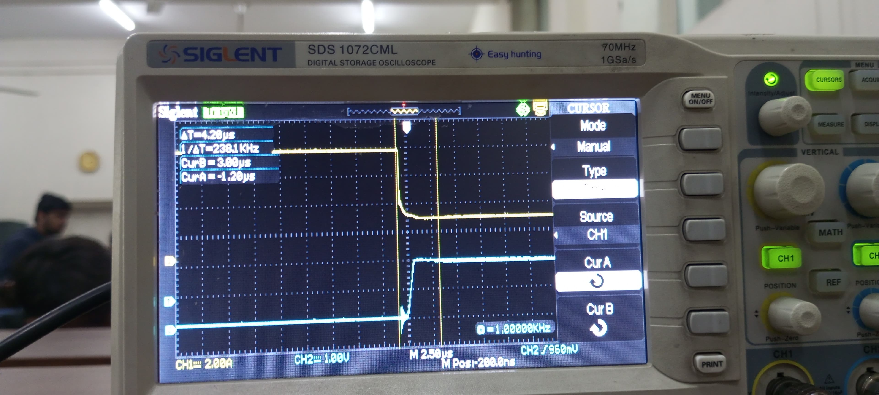

Figure 5. Input and Output waves with time delay when input is from High to Low and Output is from Low to High.

**Effect of Frequency Change on Transistor Operation**

As we know there is an insulation gap between Gate, Drain and Source in a MOSFET. As the frequency increases, the propagation delay increases because at higher frequency their isn’t sufficient time for MOSFET (transistor) to turned OFF and ON completely.Higher frequency affects the MOSFET operation due to the increase in the speed of changing insulation Gap between the Gate, Drain and Source that’s why the time delay increases.